Design Document

Contents

Introduction 1

System Overview 2

1.High Level Description 2

2.Technology Stack 3

3. Tools 3

C4 Architecture 4

System Context (C1) 4

Containers and technology (C2) 5

Components (C3) 6

Class diagram (C4) 7

Activity Diagrams 8

Content Creator 8

Customer 9

# Introduction

The purpose of this document is to outline the design for ‘Ivanti Marketplace’. This will include a view of the high level architecture. C4 architecture will be provided to show how the system will be put together and how data will flow through the system. There will also be discussion on the technologies that our team will be using throughout this project. This document provides an outline of the application workflow to demonstrate how it will be formatted

# System Overview

## 1.High Level Description

The architecture consists of 4 general layers through which the flow is being processed:

The View sends http request to the Control. If authorization/authentication is successful, the Control, calls the necessary functions from Logic. Logic then gets the necessary data from the Data layer, performs the operations and returns a DTO with the requested information to the Control. The Control then sends the data back to the View in JSON format, and finally the data is being rendered in the UI.

## 2.Technology Stack

#### Server

* **Spring Boot** ­ An open-source java micro-framework with auto configurable production-grade Spring application.
* **Gradle** - A build automation tool that controls the development process in the tasks of compilation and packaging to testing, deployment and publishing.

Spring Framework makes programming Java quicker, easier, and safer for everybody. Spring is the world’s most popular Java framework. It focuses mostly on speed, simplicity, and productivity.  
One of the many reasons to choose Spring Boot as a tool, is that it makes developing web applications with Spring Framework even faster and easier through three main capabilities:

1. Autoconfiguration  
2. An opinionated approach to configuration  
3. The ability to create standalone applications

#### Client

* **Angular**­ A typescript framework for building user interfaces

## 3. Tools

There are a number of tools and technologies that this project will utilize for development.

#### Server Side

* **JDK 11** - A set of tools for developing and testing programs written in Java and running on the Java platform
* **Spring Security** - A framework that handles authentication and authorization at the Web request level as well as the method invocation level
* **Mapstruct** – A code generator tool that greatly simplifies the implementation of mappings between Java bean types based on a convention over configuration approach
* **Auth0 Java-JWT** - An open standard (RFC 7519) that defines a compact and self-contained way for securely transmitting information between parties as a JSON object

# C4 Architecture

## System Context (C1)

## Containers and technology (C2)

## Components (C3)

## Class diagram (C4)

# Activity Diagrams

## Content Creator

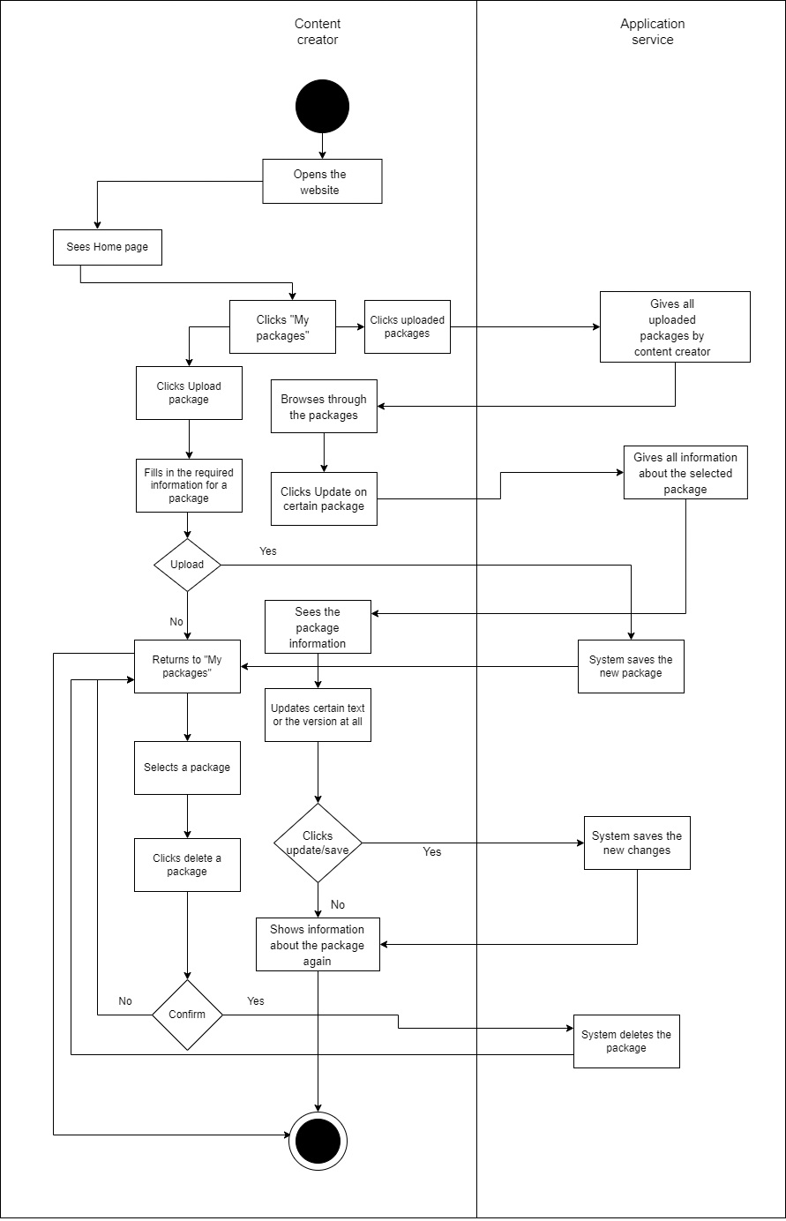

## Customer